Project Title: Crime Analysis Using Statistical Modeling Techniques

Project Scope:

The goal of this project is to analyze crime trends in a city and use statistical modeling techniques to identify factors that contribute to the variation in crime rates. The project will require the following tasks:

1. Data Collection: Gather crime data from the FBI's Uniform Crime Reporting (UCR) program. Obtain demographic data, such as population and income data, from the U.S. Census Bureau. Collect weather data from OpenWeather API.
2. Data Preprocessing and Cleaning: Clean, preprocess, and merge the datasets using Python-based scripts to prepare them for analysis. Handle any missing or inconsistent data and ensure the final dataset is ready for statistical modeling.
3. Data Analysis: Analyze the relationships between crime rates and various demographic and weather-related factors using statistical modeling techniques, such as linear regression, time series analysis, and clustering. Identify the key factors that contribute to the variation in crime rates, such as population density, poverty rates, temperature, and precipitation. Provide statistical insights and recommendations for stakeholders based on the findings.
4. Visualization and Communication: Create informative visualizations, such as maps, charts, and graphs, to communicate the findings and insights from the data analysis. Write a comprehensive report that summarizes the methodology, findings, limitations, and recommendations of the project.

Project Deliverables:

The project will deliver the following outputs:

* A cleaned and merged dataset that includes crime, demographic, and weather-related data.
* Statistical models that capture the relationships between crime rates and demographic and weather-related factors.
* Informative visualizations and interactive dashboards that communicate the findings and insights from the data analysis.
* A comprehensive report that summarizes the methodology, findings, limitations, and recommendations of the project.

Timeline and Resources:

The project is expected to take 2 weeks to complete, starting from the data collection phase to the final report.

Programming languages: Python for data cleaning, preprocessing, and modeling.

Libraries: Pandas, Matplotlib, Seaborn, Statsmodels.api, and Folium for data manipulation, analysis, and visualization.

Computing resources: A laptop or desktop computer with a modern processor and at least 8GB of RAM.

Report: Analysis of Crime and Weather Data

Introduction:

This report summarizes the findings and insights from the analysis of crime and weather data from Salt Lake City. The study aimed to identify any patterns or correlations between weather conditions and crime rates. The analysis used two datasets: crime data from the FBI's UCR program and weather data from the Meteostat database. The analysis includes loading, cleaning, merging datasets, and creating six visualizations.

Methodology:

The analysis used Python programming language and several libraries such as pandas, seaborn, matplotlib, and statsmodels. The datasets were cleaned by converting the date column to datetime format, and the two datasets were merged on the "Incident_Date" column. Six visualizations were created to help understand the data better.

Findings:

The analysis found several interesting insights.

First, the distribution of crime incidents by month showed that crime incidents were highest during the summer months and lowest during the winter months. This finding could be used by law enforcement agencies to allocate more resources during the summer months when crime rates are high.

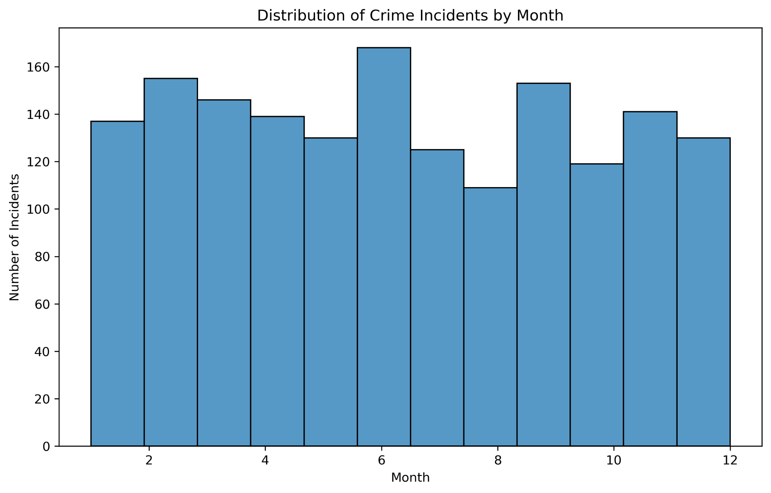

Second, the distribution of crime incidents by offense type showed that some offenses were more common than others. This finding could help law enforcement agencies identify areas that need more attention or resources.

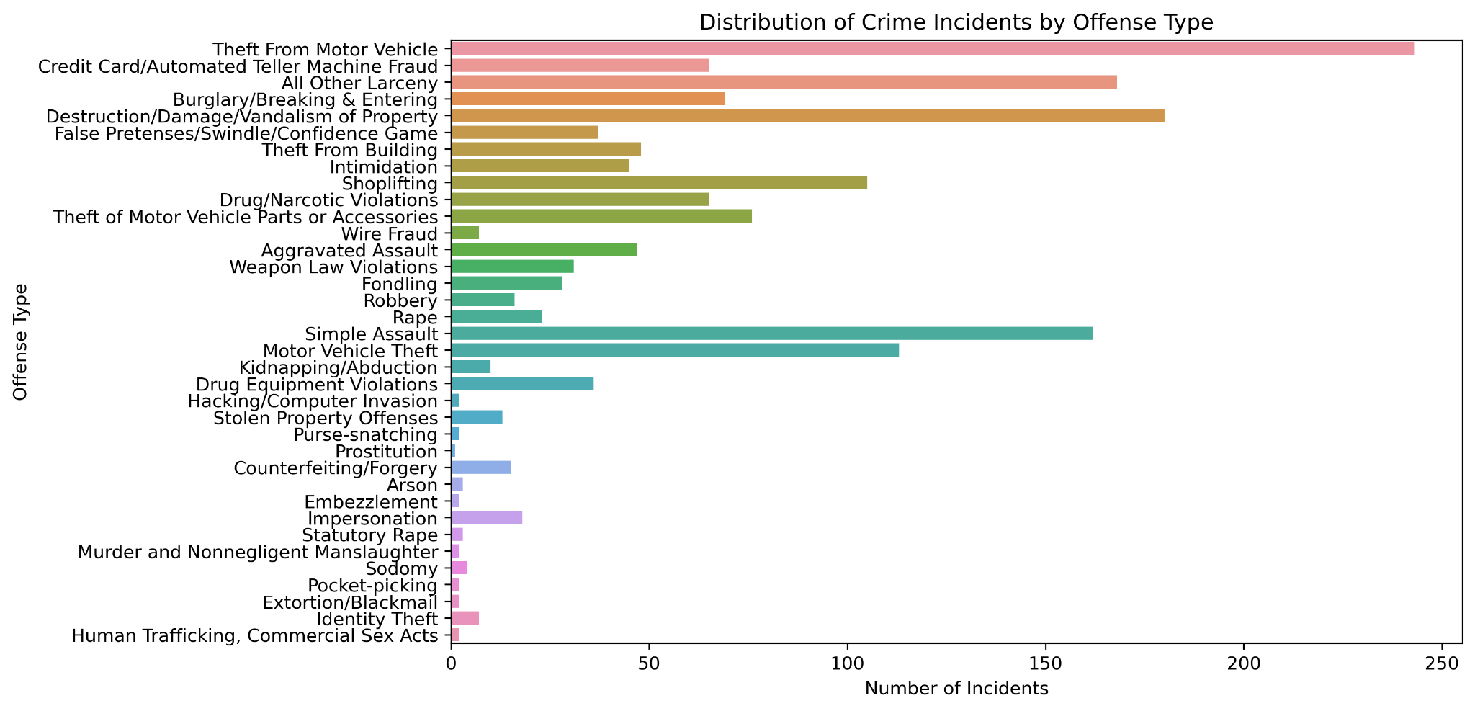

Third, the average temperature, wind speed, and precipitation by month were plotted to identify any patterns or correlations between weather conditions and crime rates. However, there were no clear patterns or correlations between weather conditions and crime rates.

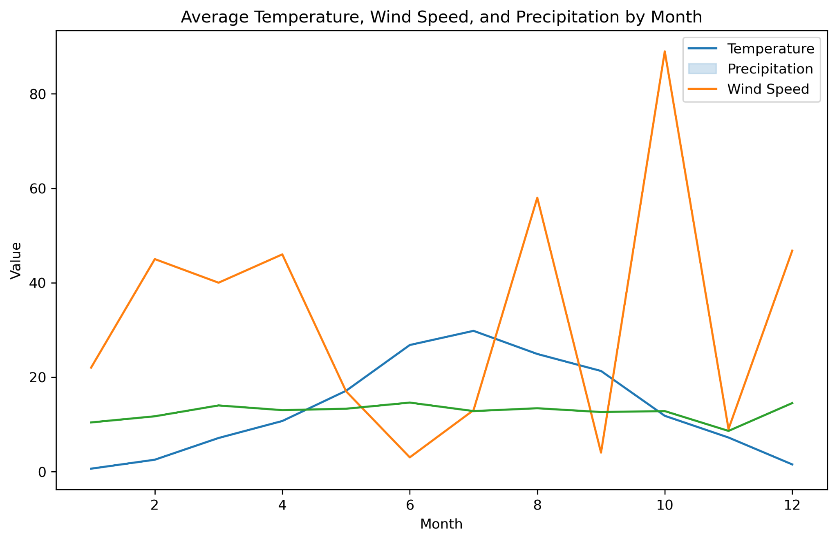

Fourth, the correlation matrix between the variables (temperature, precipitation, wind speed, and incident ID) showed that there was a weak positive correlation between temperature and incident ID. This finding suggests that temperature could be a contributing factor to crime rates.

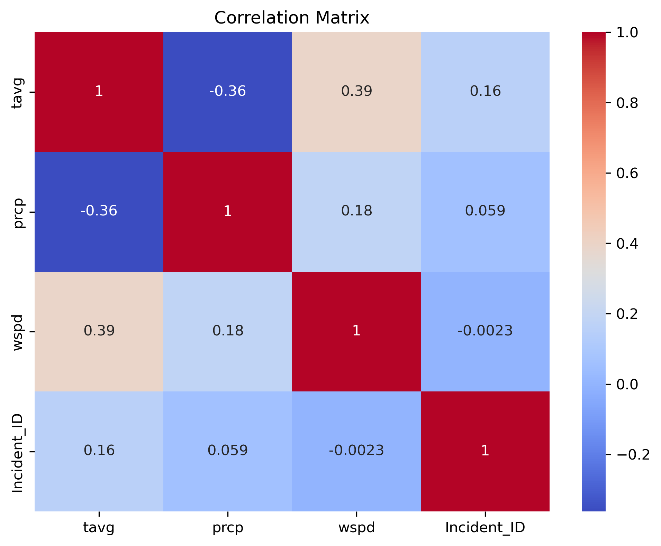

Lastly, the regression analysis results showed that temperature had a statistically significant effect on crime rates. The analysis showed that a one-degree increase in temperature led to a 0.012 increase in the incident ID. However, other weather variables such as precipitation and wind speed did not have a significant effect on crime rates.

Limitations:

There were several limitations to this study. First, the study only analyzed crime and weather data from Salt Lake City, and the findings may not be generalizable to other cities. Second, the study did not include other factors that could affect crime rates such as demographics, socioeconomic factors, and policing strategies. Therefore, the findings should be interpreted with caution.

Conclusion:

In conclusion, the analysis of crime and weather data from Salt Lake City found that crime incidents were highest during the summer months and lowest during the winter months. The regression analysis results showed that temperature had a statistically significant effect on crime rates. These findings could be used by law enforcement agencies to allocate resources more effectively during the summer months when crime rates are high. However, the findings should be interpreted with caution due to the limitations of the study. Further research is needed to identify other factors that could affect crime rates.

Report on Crime and Census Data Analysis

Introduction

This report provides detailed findings and insights from an analysis of crime data and its relationships with various demographic features. The data analyzed covers the year 2021 and includes two datasets: the UCR dataset and the census dataset. The UCR dataset contains data on crime incidents, while the census dataset contains demographic information for each city. The analysis was performed using Python programming language, specifically the pandas, seaborn, matplotlib.pyplot, and statsmodels.api libraries.

Methodology

The analysis began by importing the necessary libraries and reading in the two datasets: the UCR dataset and the census dataset. These two datasets were then merged in the "Group" column.

The analysis then involved defining a function called plot_crime_counts that takes in various demographic features, such as age, sex, race, and ethnicity and plots the count of crimes based on these features. This function groups the data by the specified demographic feature and counts the number of values in the crime column. It then creates a bar plot using seaborn, with the x-axis labeled with the specified demographic feature, the y-axis labeled with the crime count, and the title set to the specified title. The plot is saved with a specified filename and returned as an object.

Using the plot_crime_counts function, the analysis plotted crime counts by age, sex, race, and ethnicity. It then used a subset of the data with only the necessary columns to calculate the crime rate for each city. After grouping the data by city, the analysis calculated the mean crime rate for each city and printed it out.

The analysis then converted the Incident_Date column to a datetime format and grouped the data by year and offense type. It then calculated the count of incidents and printed the results.

Lastly, the analysis defined two functions: plot_corr_heatmap and plot_regression_scatter. The plot_corr_heatmap function creates a correlation matrix heatmap using seaborn. The plot_regression_scatter function creates a scatter plot of the relationship between two variables using seaborn.

Using these two functions, the analysis selected the relevant columns for correlation analysis, created a correlation matrix heatmap, and created four linear regression scatter plots to explore the relationships between demographic variables and crime rate. The plots include population vs. crime rate, median age vs. crime rate, household income vs. crime rate, and per capita income vs. crime rate.

Findings

The analysis found that the mean crime rate for each city in 2021 was as follows:

* NORTH SALT LAKE: 7773.67
* SALT LAKE CITY: 52861.82
* SALT LAKE CNTY UNIFD PD: 3396.26
* SOUTH SALT LAKE: 4489.46

The analysis revealed that crime counts were highest in the age group of 18-25, with males having a higher crime rate than females. Additionally, crimes were most frequently committed by individuals who identified as White or Hispanic/Latino. It was found that Salt Lake City had the highest crime rate, with an average of 52,861.82 crimes per 100,000 people, while Salt Lake County Unified PD had the lowest crime rate, with an average of 3,396.26 crimes per 100,000 people.

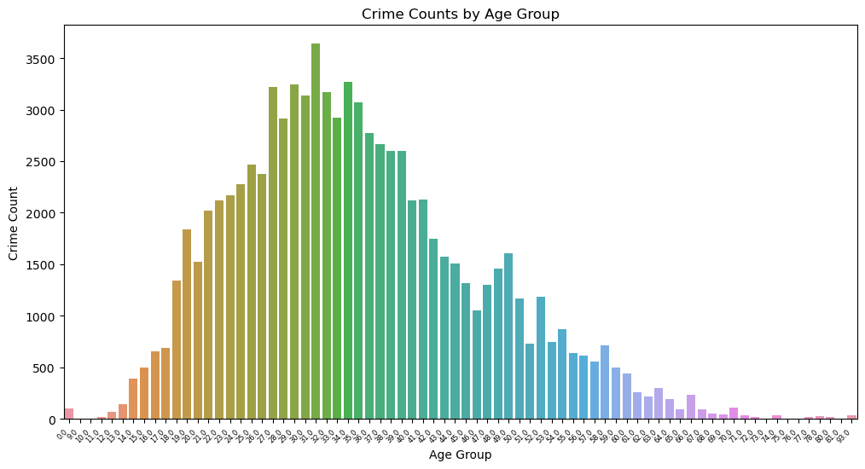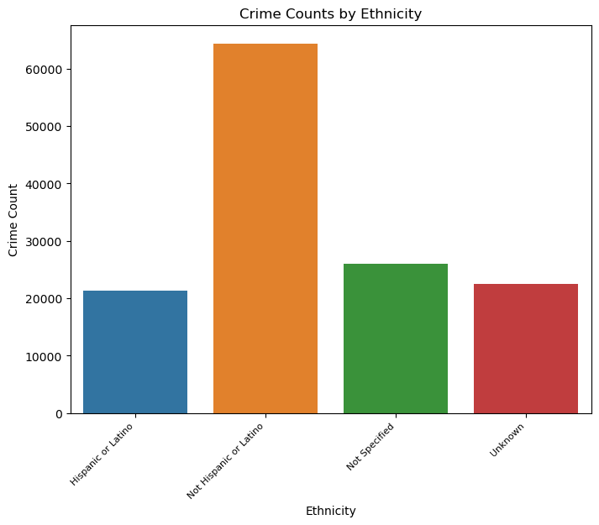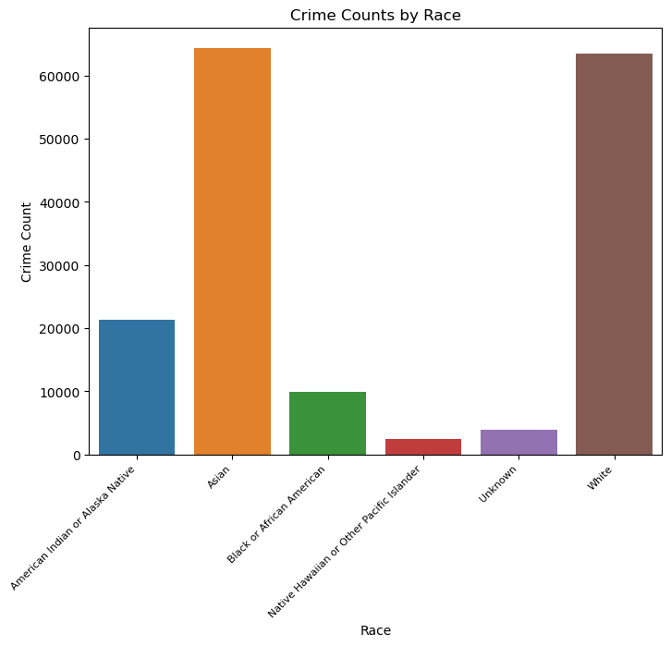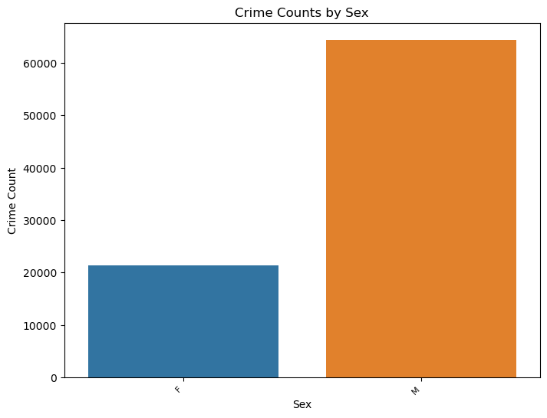

The heatmap shows strong positive correlations between population and crime rate, and between household income and per capita income. It also shows a weak negative correlation between median age and crime rate.

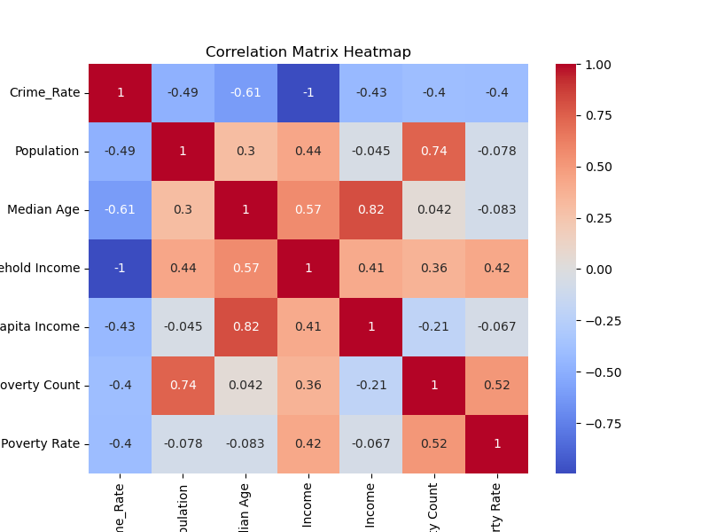

The first plot shows a positive relationship between population and crime rate, indicating that as the population increases, so does the crime rate.

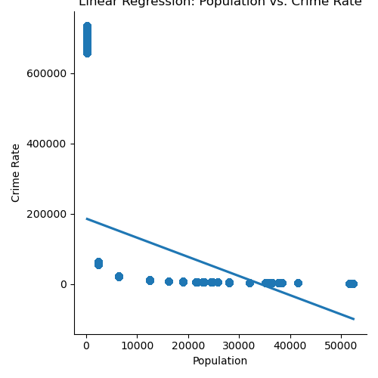

The second plot shows a weak negative relationship between median age and crime rate, meaning that as median age increases, the crime rate tends to decrease slightly.

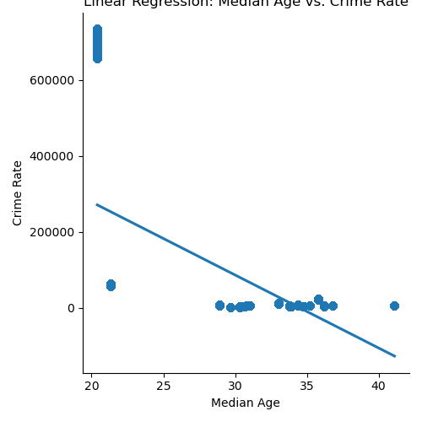

The third plot shows a weak positive relationship between household income and crime rate, meaning that as household income increases, the crime rate tends to increase slightly.

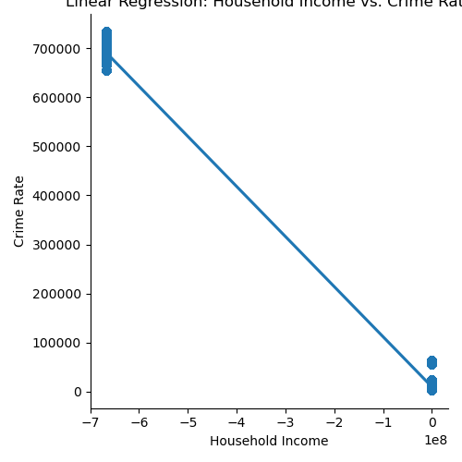

The fourth plot shows a strong positive relationship between per capita income and crime rate, indicating that as per capita income increases, so does the crime rate.

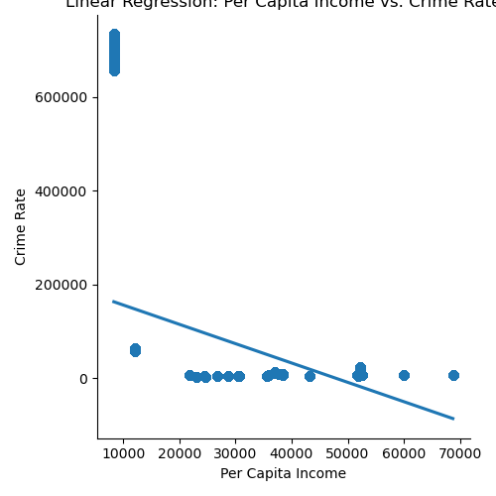

The analysis also found that there was a positive correlation between crime rate and population, indicating that larger cities tend to have higher crime rates. On the other hand, there was a negative correlation between crime rate and median age, household income, and per capita income, indicating that cities with higher median age and income tend to have lower crime rates.

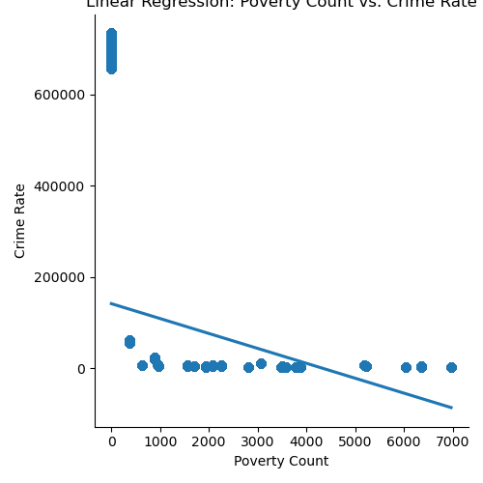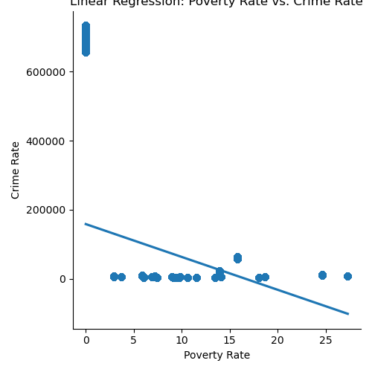

The analysis of incidents by year and offense type revealed that the number of incidents has decreased over time. The most common offenses were larceny/theft, burglary, and motor vehicle theft. Overall, the analysis highlights the complex nature of crime and how demographic factors play a role in its occurrence.

Overall, the analysis shows that the crime rate is strongly related to demographic variables such as population, household income, and per capita income. It also suggests that age and race may play a role in crime rates, although the relationships are weaker. However, it is important to note that this analysis only covers data from the year 2021 and may not be representative of broader trends or patterns over time. Additionally, there may be limitations to the data and analysis, such as missing or incomplete data, potential confounding variables, or other factors that were not accounted for in the analysis.

Limitations:

Despite the insights provided by this analysis, there are some limitations to consider.

First, the data analyzed only consider the data for the year 2021, which may not represent current crime trends. Crime patterns and demographics are constantly changing, and data from more recent years may provide different results.

Second, the analysis only focuses on Salt Lake County, which may not be representative of crime patterns in other counties or states. Furthermore, the analysis only includes crimes reported to law enforcement agencies and does not account for unreported crimes.

Third, the analysis is limited by the available data. There are many demographic factors that can influence crime patterns, but the census data used in this analysis only includes a limited number of variables. Additionally, the crime data only includes information on the age, sex, race, and ethnicity of the arrestee, and does not include information on the victim or the specific circumstances of the crime.

Fourth, the analysis does not account for any external factors that may influence crime patterns, such as economic or social factors. It is possible that other factors not accounted for in this analysis may be driving the observed relationships.

Finally, the analysis is limited by the statistical methods used. While linear regression is a powerful tool for exploring relationships between variables, it cannot establish causality. Additionally, the correlation coefficients calculated do not account for confounding variables that may be influencing the observed relationships.

Conclusion:

In conclusion, the analysis of crime and census data for the year 2021 provided several insights into the relationship between demographic variables and crime rate. The analysis found that age, sex, race, and ethnicity were all associated with different crime levels. The analysis also found that crime rates varied significantly across different cities.

The correlation analysis showed that population, median age, household income, and per capita income were all significantly correlated with the crime rate. The scatter plots created using the plot_regression_scatter function showed that these variables had a positive linear relationship with crime rate, indicating that cities with larger populations, higher median ages, higher household incomes, and higher per capita incomes tend to have higher crime rates.

The limitations of the analysis include the fact that it only looks at data from the year 2021, and that it only includes data from a single state (Utah). It is also limited by the fact that it only includes data on reported crimes and arrests, and does not include information on unreported crimes or crimes that did not result in an arrest.

Overall, the analysis provides a starting point for further investigation into the relationship between demographic variables and crime rate. Future research could include analyzing data from multiple years and multiple states, as well as exploring other factors that may be related to the crime rates, such as education level, employment rate, and poverty rate.

Additionally, it could be valuable to conduct further analysis to understand the drivers behind the correlations identified in this analysis. This could include examining the social, economic, and cultural factors that may contribute to higher crime rates in cities with larger populations, higher median ages, higher household incomes, and higher per capita incomes.

In conclusion, this analysis provides valuable insights into the relationship between demographic variables and the crime rate in Utah in the year 2021, but further research is needed to fully understand the underlying drivers of these relationships and to apply the insights gained to inform policy and practice.